ARCHITECTURE DIAGRAM FOR LIBRARY MANAGEMENT APPLICATION

Library management application is cloud native Spring boot application built with Angular JS as UI. It involves basic functionality of CRUD. Shown below is the schematic of the high-level architecture plan involved.

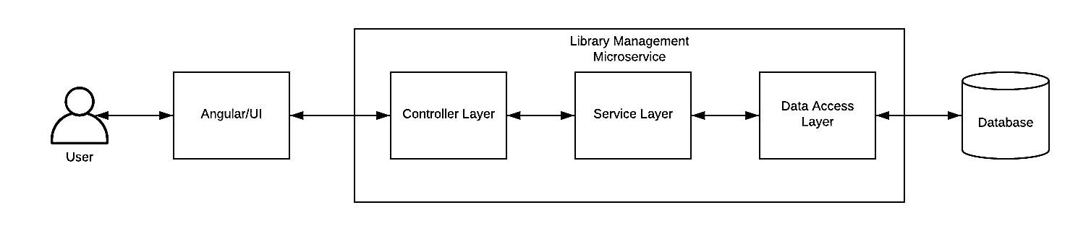
Fig 1. High-level Architecture Plan

Screenshots

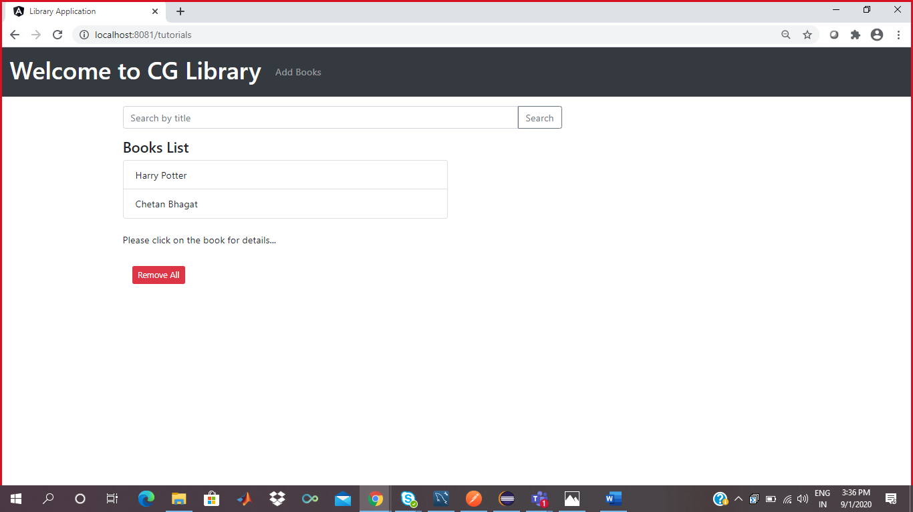
Screenshot of Home Page

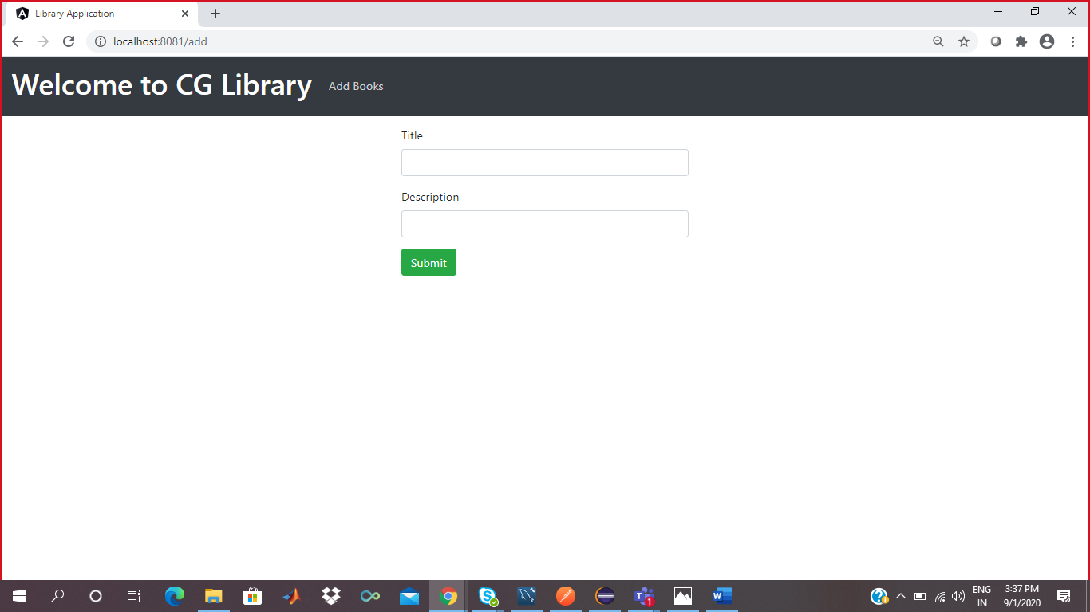
Screenshot of Add Page

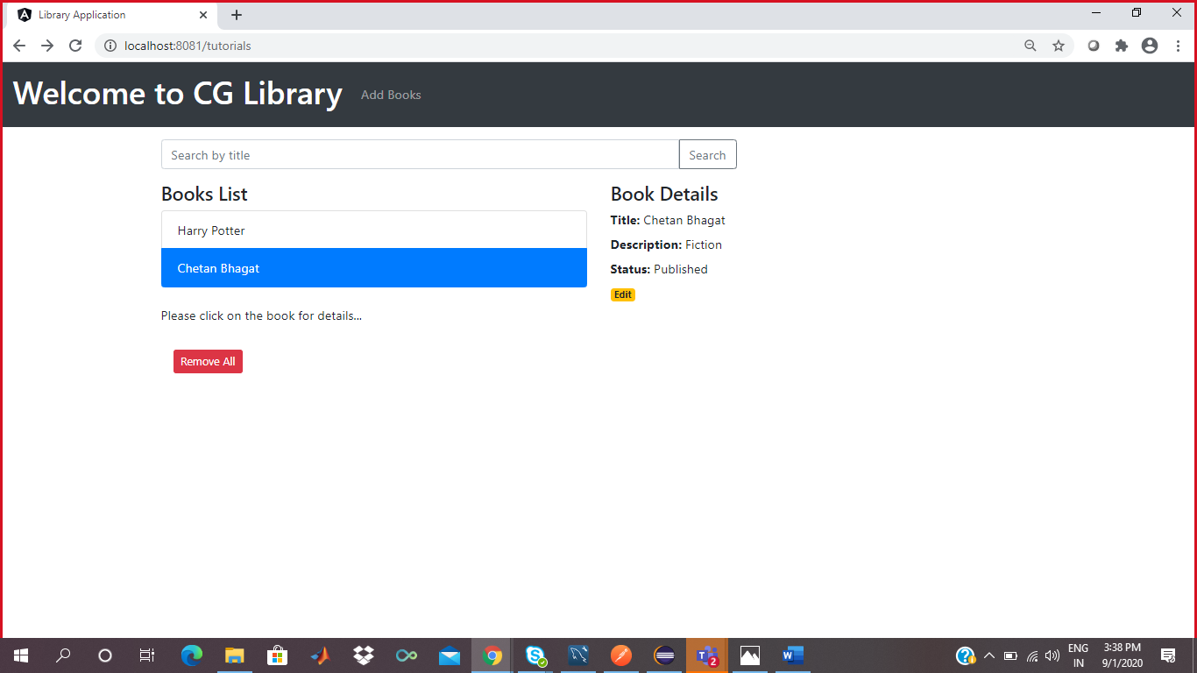
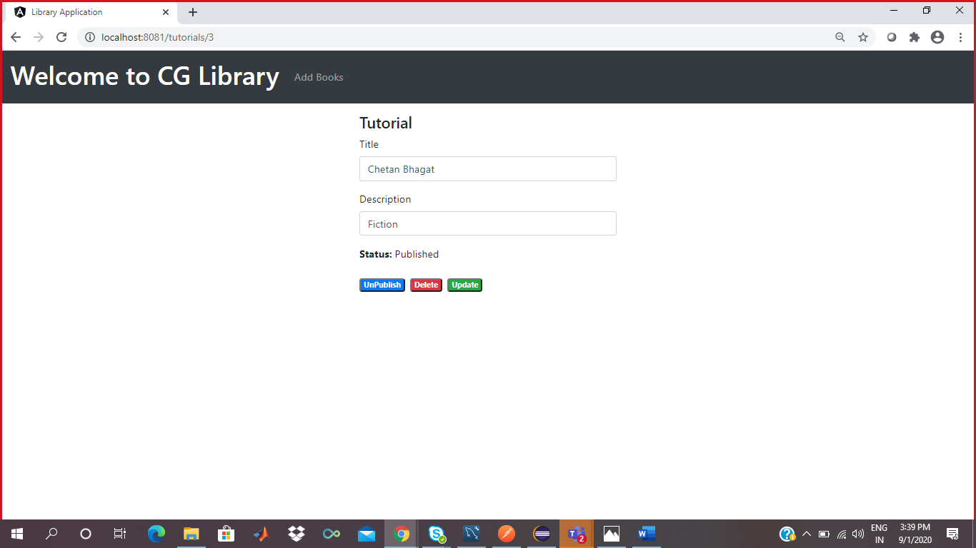
Screenshot of Update page

